**Name: Session:**

**Programming II**

**Lab Exercise 3.15.2022**

1. Create an application that displays a table of Celsius temperatures 0 to 20 and their Fahrenheit equivalents. The application should loop to display the temperatures in a list box. Remember the formula is:

F = 1.8 * C + 32

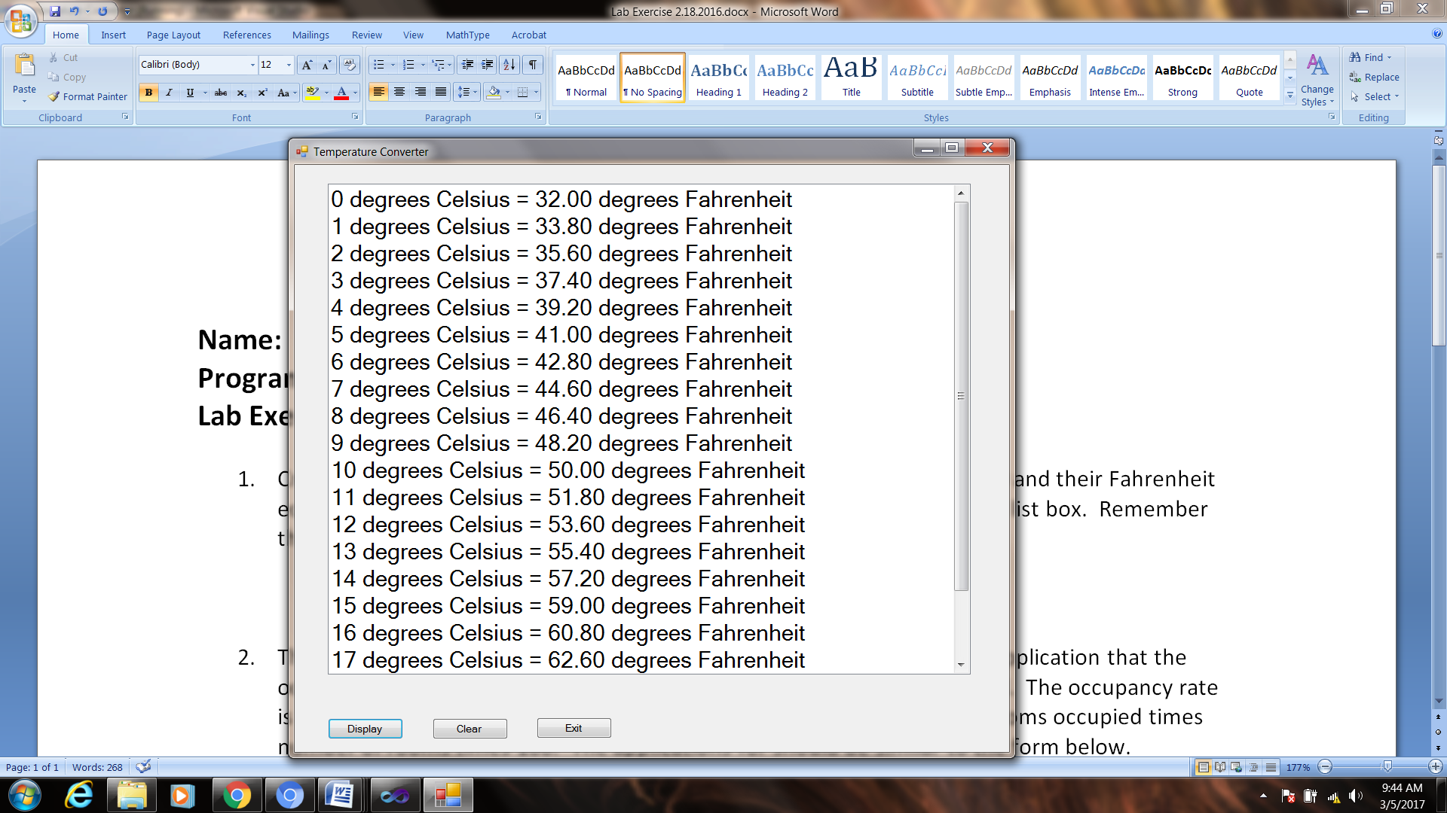

1. The El Grande Hotel has 8 floors and 30 rooms on each floor. Create an application that the occupancy rate for each floor and the overall occupancy rate for the hotel. The occupancy rate is the percentage of rooms occupied. Occupancy rate is in percentage; rooms occupied times number of rooms times 100. The applications for should be similar to the form below.

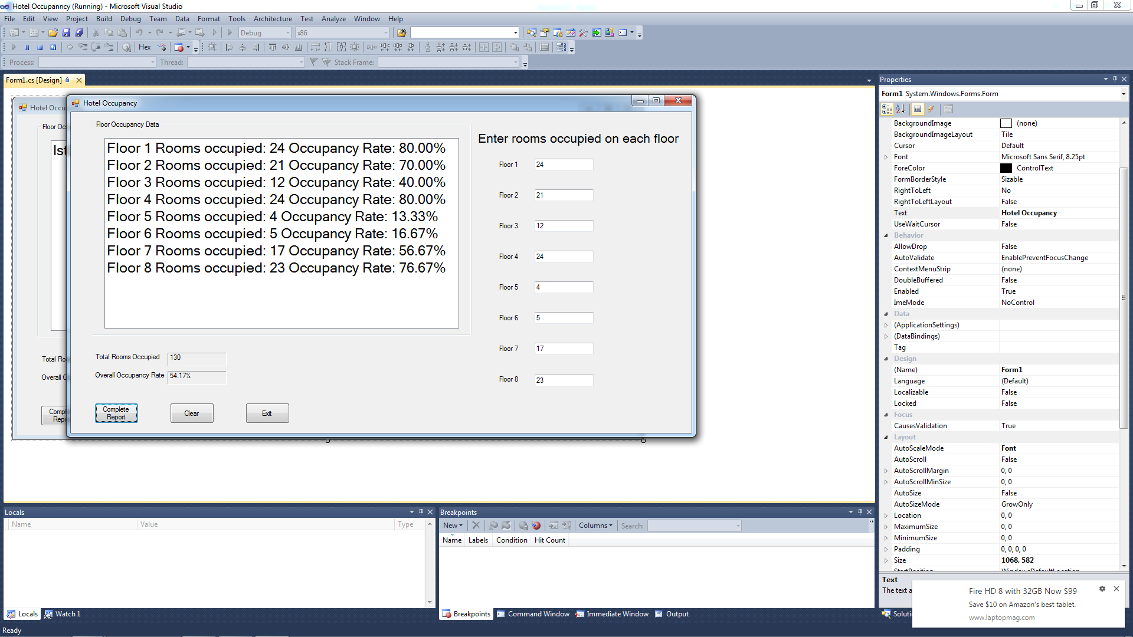

When the user clicks the Complete Report button, the program will loop 8 times and display the information for that floor in the list box. When the data has been calculated for all floors, the application should display the total number of rooms occupied and the overall occupancy rate for the hotel. The Clear button should clear the appropriate values on the form and the Exit button should exit the program.

**When you have completed application 1 and 2, submit a screen shot of your running program as well as the source code.**